**Software Architecture Android Lab Exam May 2024**

Create an application “ TrainLinesStationsHours” with the following functionality (remember that you do not have to save the data persistently either on the server or locally, and it is essential that the application has all the necessary model classes and a subclass of Application functioning as DAO).

Start building from one of the attached projects, which correspond to practice 3.

-In the main activity MainLinesActivity (1.5 points):

* A list of train lines is displayed with the origin and end station,
* Clicking on an element in the list opens the activity LineStationsActivity ,
* Clicking on the floating button + opens activity NewLineActivity.

In NewLineActivity (1.5 points):

* You can create a new line: origin station and destination station.
* Clicking on the save button saves the line and returns to MainLinesActivity where the new line will be displayed .

- In LineStationsActivity (2 points):

* A list of intermediate stations that the train passes through is displayed,
* Clicking on an element in the list opens the activity StationHoursActivity,
* Clicking on the floating button + opens activity NewStationActivity.

In NewStationActivity (1.5 points):

* For the corresponding line, an intermediate station can be created: intermediate station name and distance to the source station.
* Clicking on the save button saves the intermediate station, closes the activity and returns to LineStationsActivity where the new station will be displayed.

At StationHoursActivity (2 points):

* A list is displayed with the departure times of the trains that stop at that station,
* activity opens NewStationHourActivity .

In NewStationHourActivity (1.5 points):

* For the corresponding station you can create a new schedule: destination station and departure time.
* By clicking on the save button the schedule is saved, the activity closes and you return to StationHoursActivity where the new schedule will be displayed.

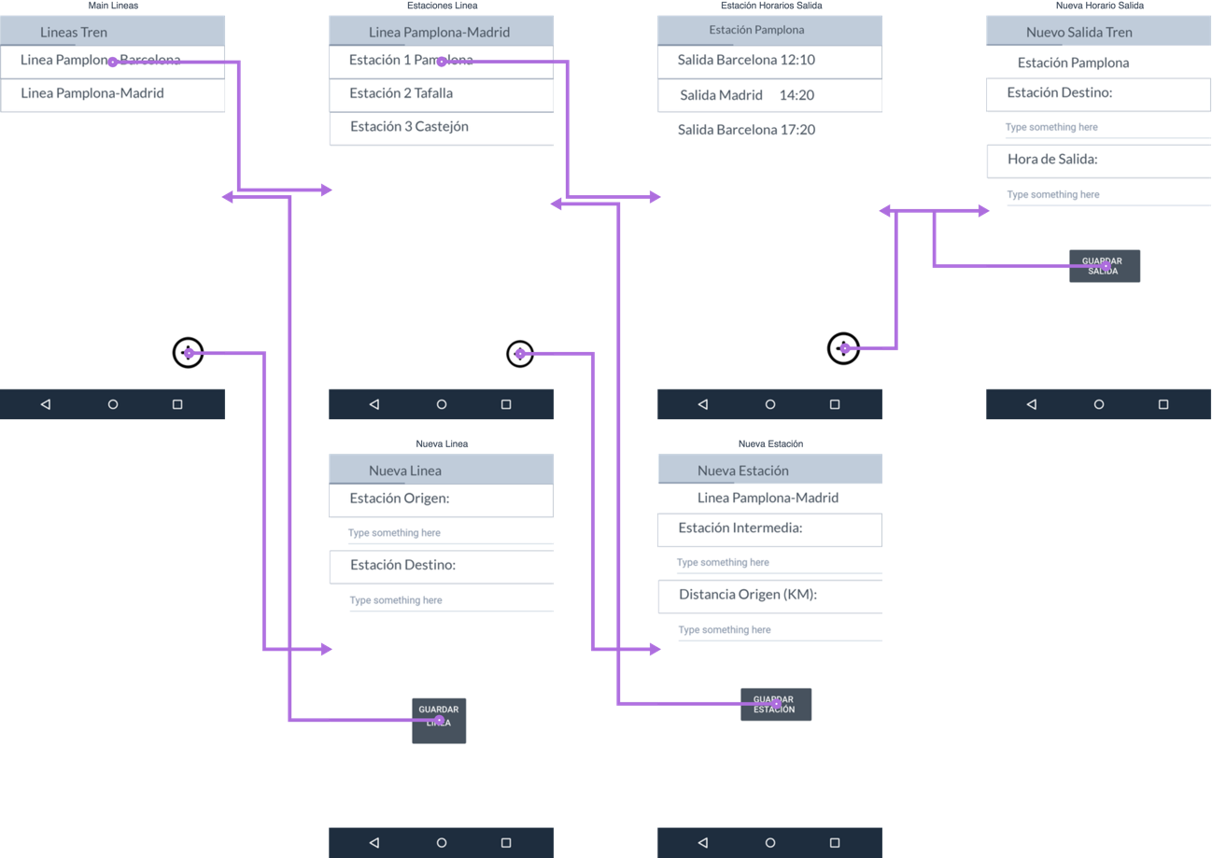_____________

Submit to the MiAulario assigment:

-a . zip folder created with Studio export,

(if you have made changes that you have not been able to compile or execute, leave them commented in the code)

Correction criteria:

* For each functionality/screen/activity:
  + 0 points if it is not executed when selecting the button from which it should be started.
  + Upto 1.5 or 2 points if the requested functionality is correctly implemented.
  + Substract upto 1.5 point if the required Model class, and attributes and methods of the subclass of Application are not correct for the corresponding functionality.